TensorFlow

1. Dataset

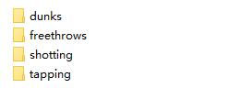(Data_Category.jpg)

We have 4 categories. And each category has 50 images for training and test part.

(The 50 mainframes were generated by spark code we used before)





(Four_categories.jpg)

And then we change the data format to MNIST data.

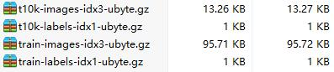(MNIST_data.jpg)

Our dataset preparation done.

1. Training and test in TensorFlow

Copy the MNIST data to each of TensorFlow approaches folder.

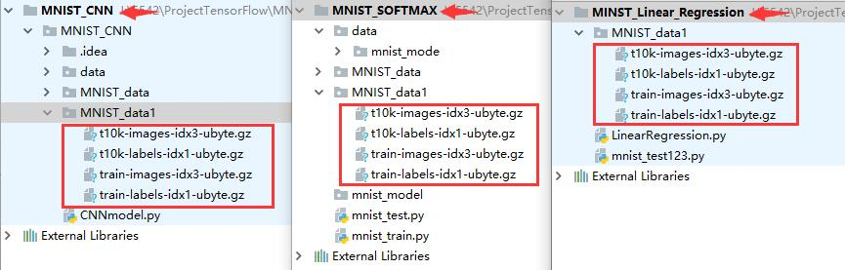

(CopyMnistData.jpg)

The common parameters for each method.

1. MNIST validation size is 40
2. Epochs: 500
   1. **Linear Regression**

2.1.1 Parameters setting:

(LR1.jpg)

2.1.2 Results

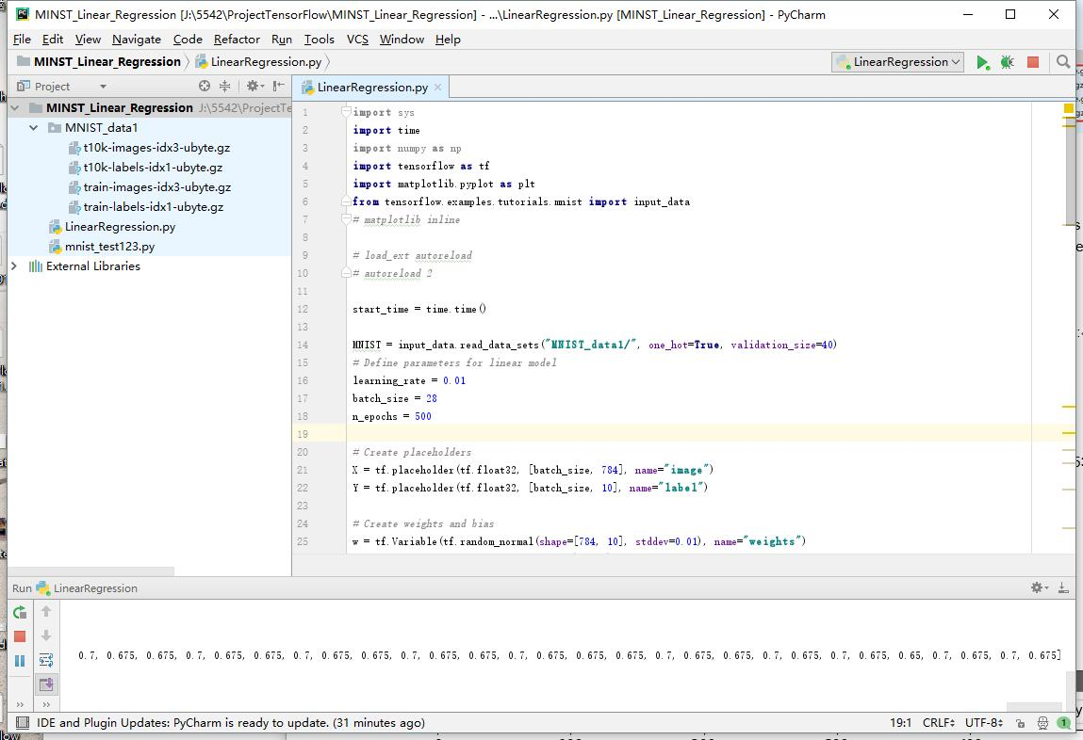

(LR2.jpg)

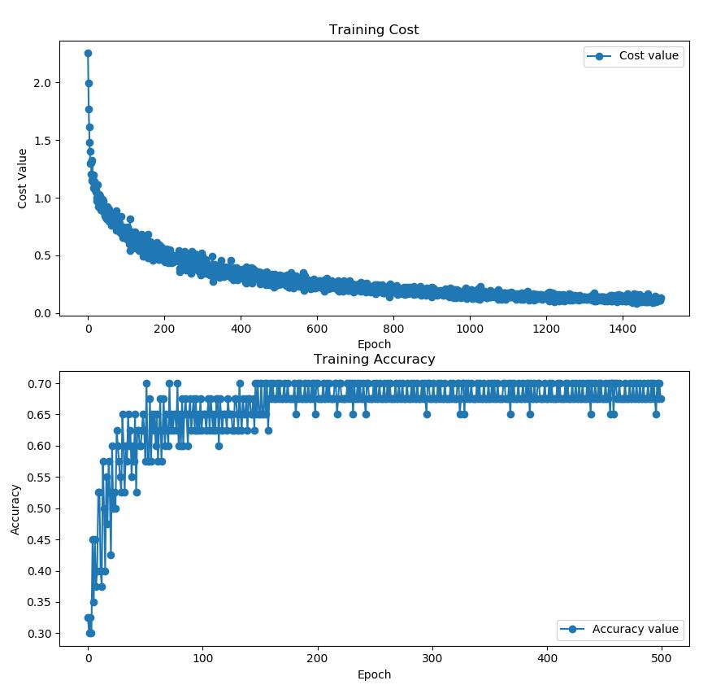

(LR_TraingCost_Accuracy.jpg)

1. **Running Time: 33.87053728103638 seconds**
2. **Accuracy: 0.675**
   1. **SoftMax**
      1. Parameters setting: None

There are two .py files to build model and test. We combine them in order to calculate the time the running cost.

* + 1. Results

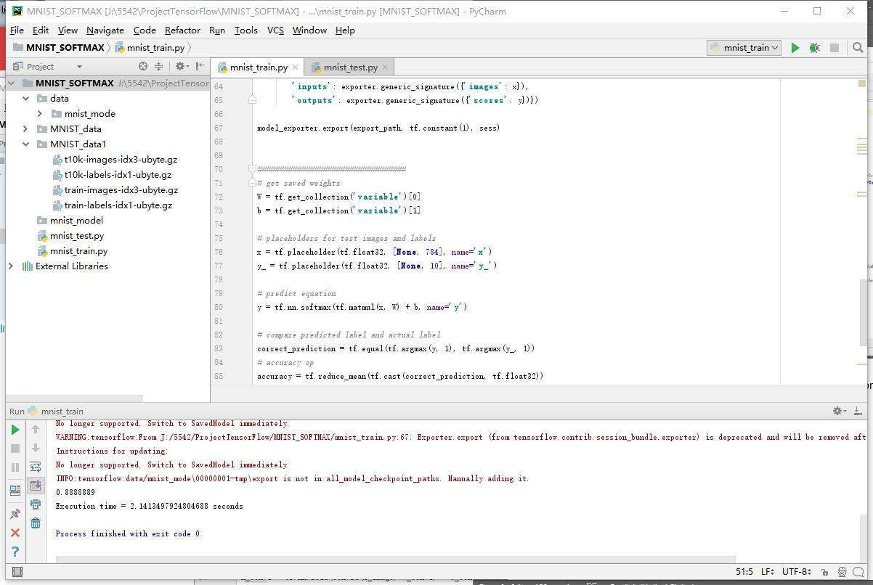

(SoftMax1.jpg)

1. **Running Time: 2.1413497924804688 seconds**
2. **Accuracy: 0.8888889**
   1. **CNN**

2.3.1 Parameters setting:

(1) weight_variable and bias_variable are 0.1 and 0.1

(2) The Optimizer we use is: AdamOptimizer(1e-4)

(3) Filter size is: 32-64-1024

* + 1. Results

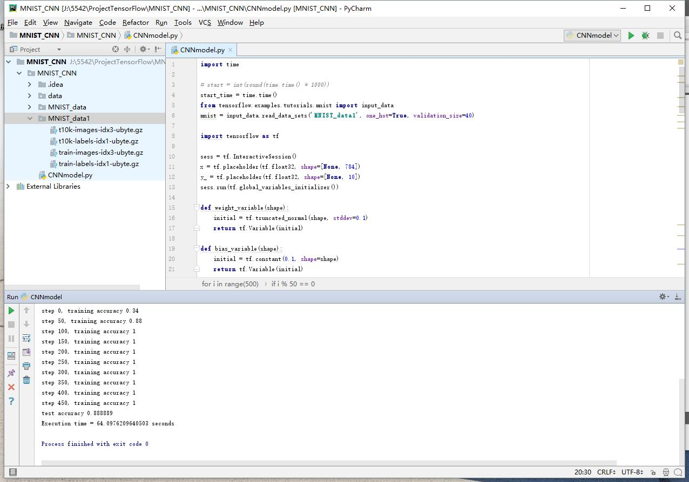

(CNN1.jpg)

1. **Running Time: 64.0976209640503 seconds**
2. **Accuracy: 0.888889**
   * 1. Changing epochs

We can see the results; the training accuracy always is 1 after step100. So, we changed epoch to 100 and see what happen.

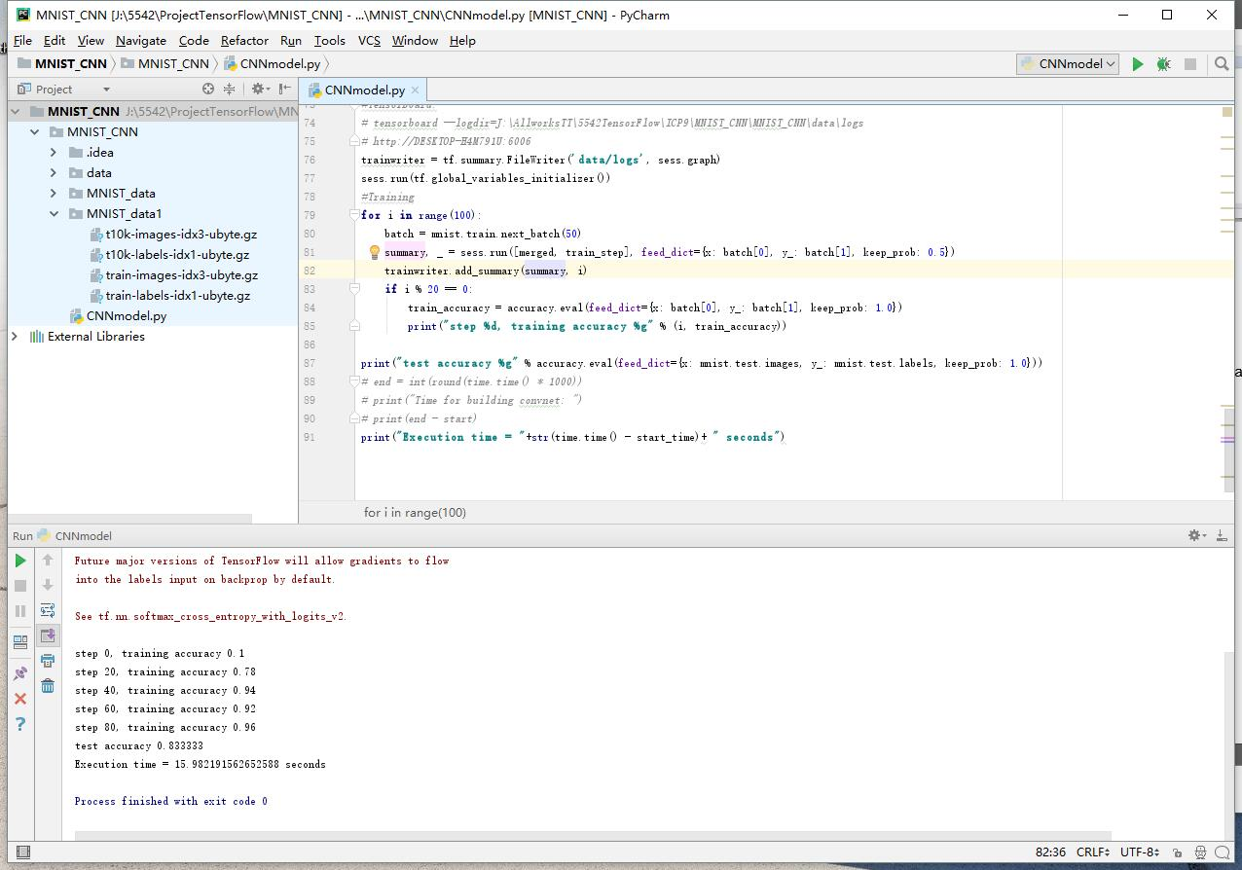

(CNN2)

1. **Running Time: 15.982191562652588 seconds**
2. **Accuracy: 0.833333**